**Mini Project : Bangalore Restaurant Price Prediction on Zomato**

**Objective:**

The primary objective of this analysis is to predict the "Approximate Cost" for two people at various restaurants listed on Zomato in Bangalore. By analyzing key attributes such as ratings, customer votes, restaurant type, location, and cuisine variety, this project aims to identify the factors that most significantly influence the average cost for dining, thereby helping users make informed decisions based on budget and preferences.

**Problem Statement:**

With Zomato's extensive presence in Bangalore, one of India’s major tech hubs and an area with high demand for food delivery and dining options, it is essential to understand the pricing structure across restaurants in the city. The challenge is to leverage the data to accurately predict the approximate dining cost for two people. By performing a price prediction analysis, this project will answer questions such as:

* 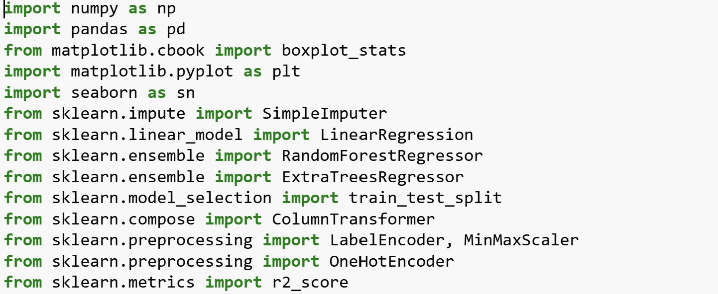Which factors (e.g., rating, restaurant type, location) have the greatest impact on pricing?
* Can a predictive model be developed to estimate the dining cost based on these attributes? - How can Zomato optimize price-related recommendations for users, enhancing the user experience and improving customer satisfaction?

This analysis can ultimately offer insights for Zomato to refine its pricing strategies, enhance user satisfaction, and increase engagement with its platform.

# Data Collection and Preparation

**Data Collection**

**a. Load the Dataset and Verify its Integrity**

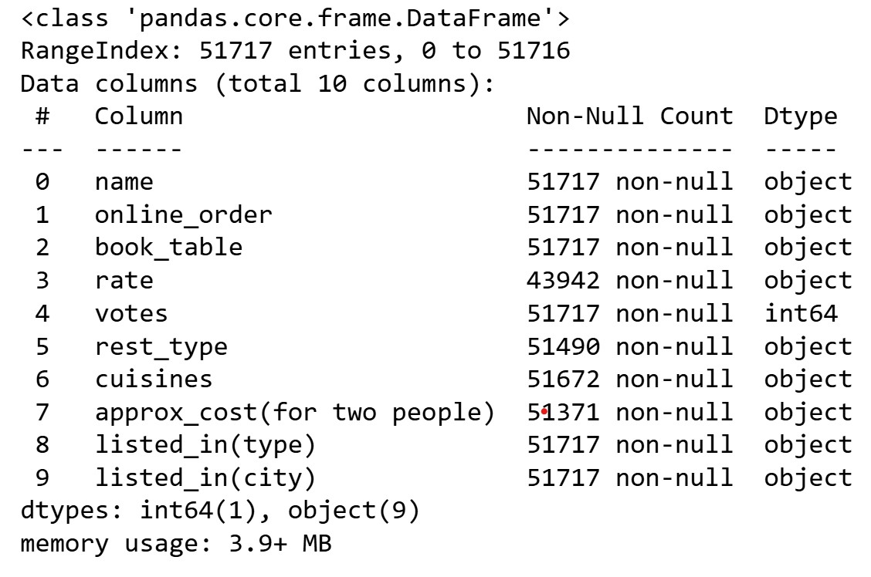

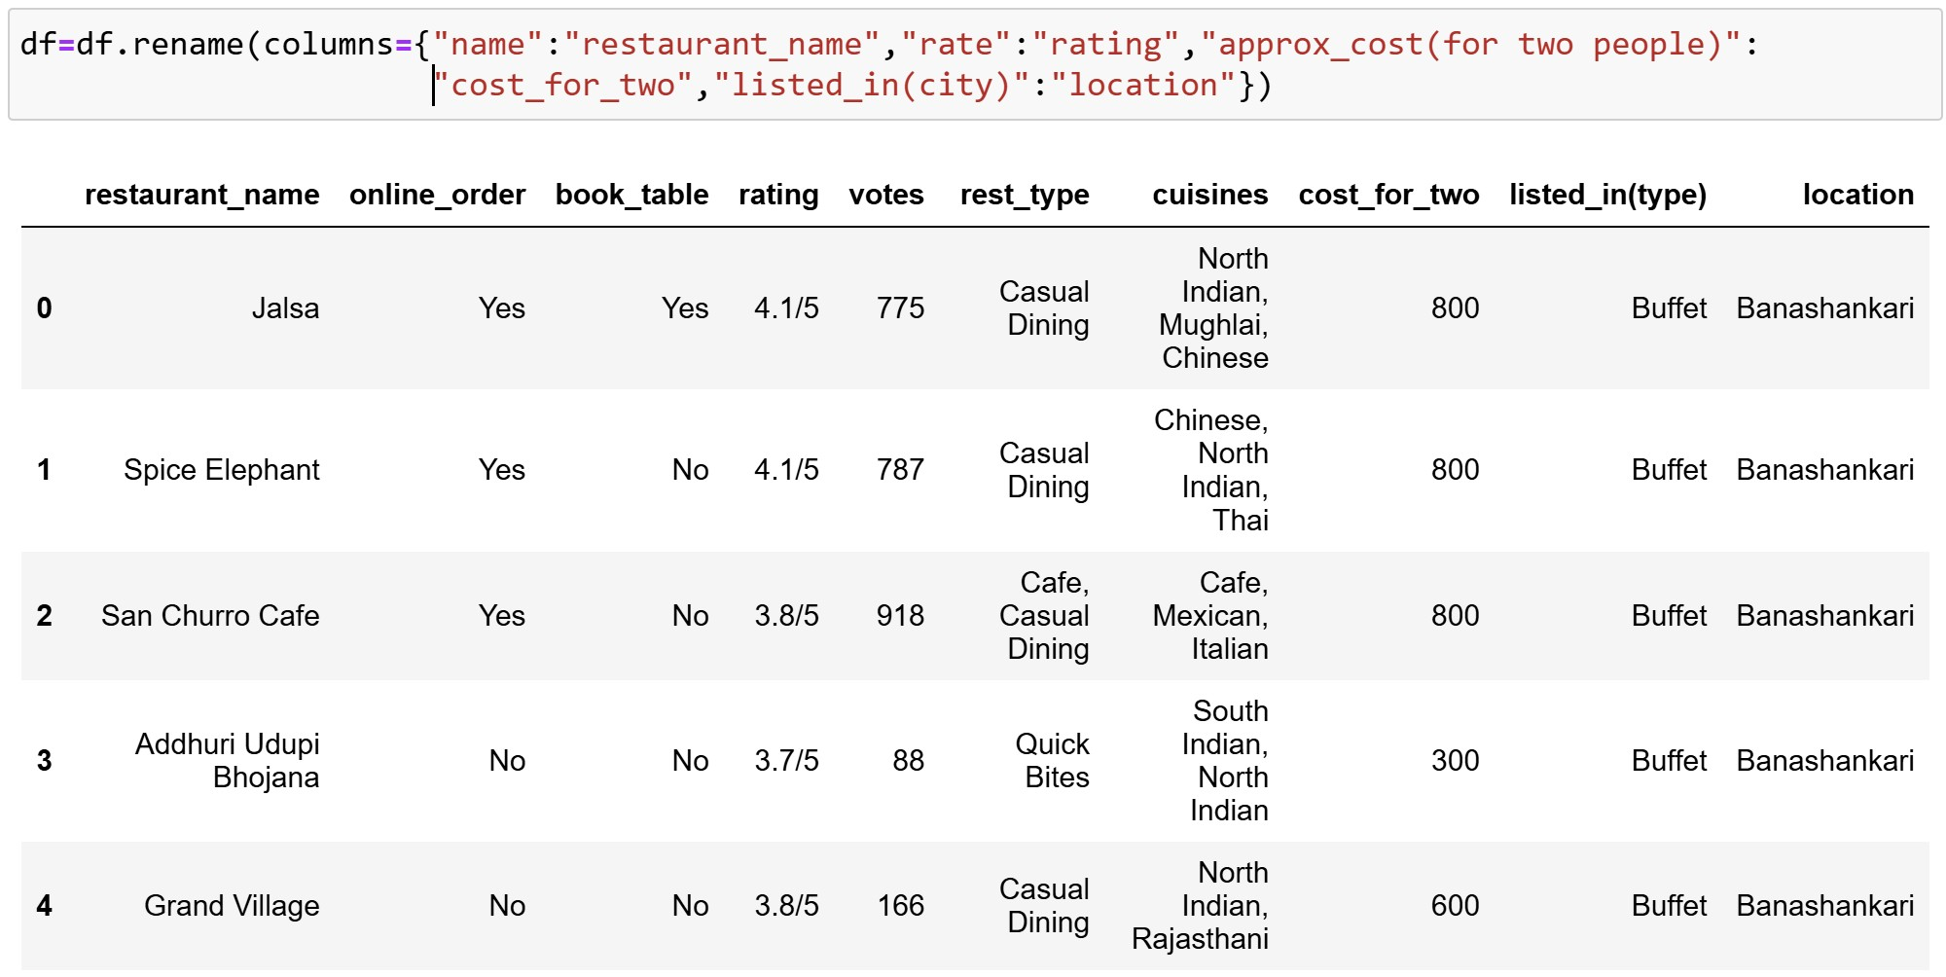

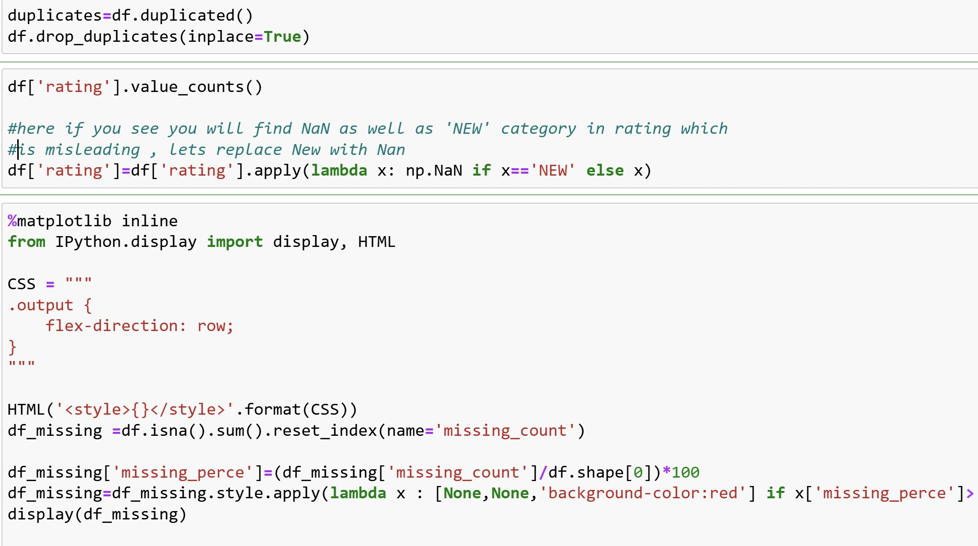

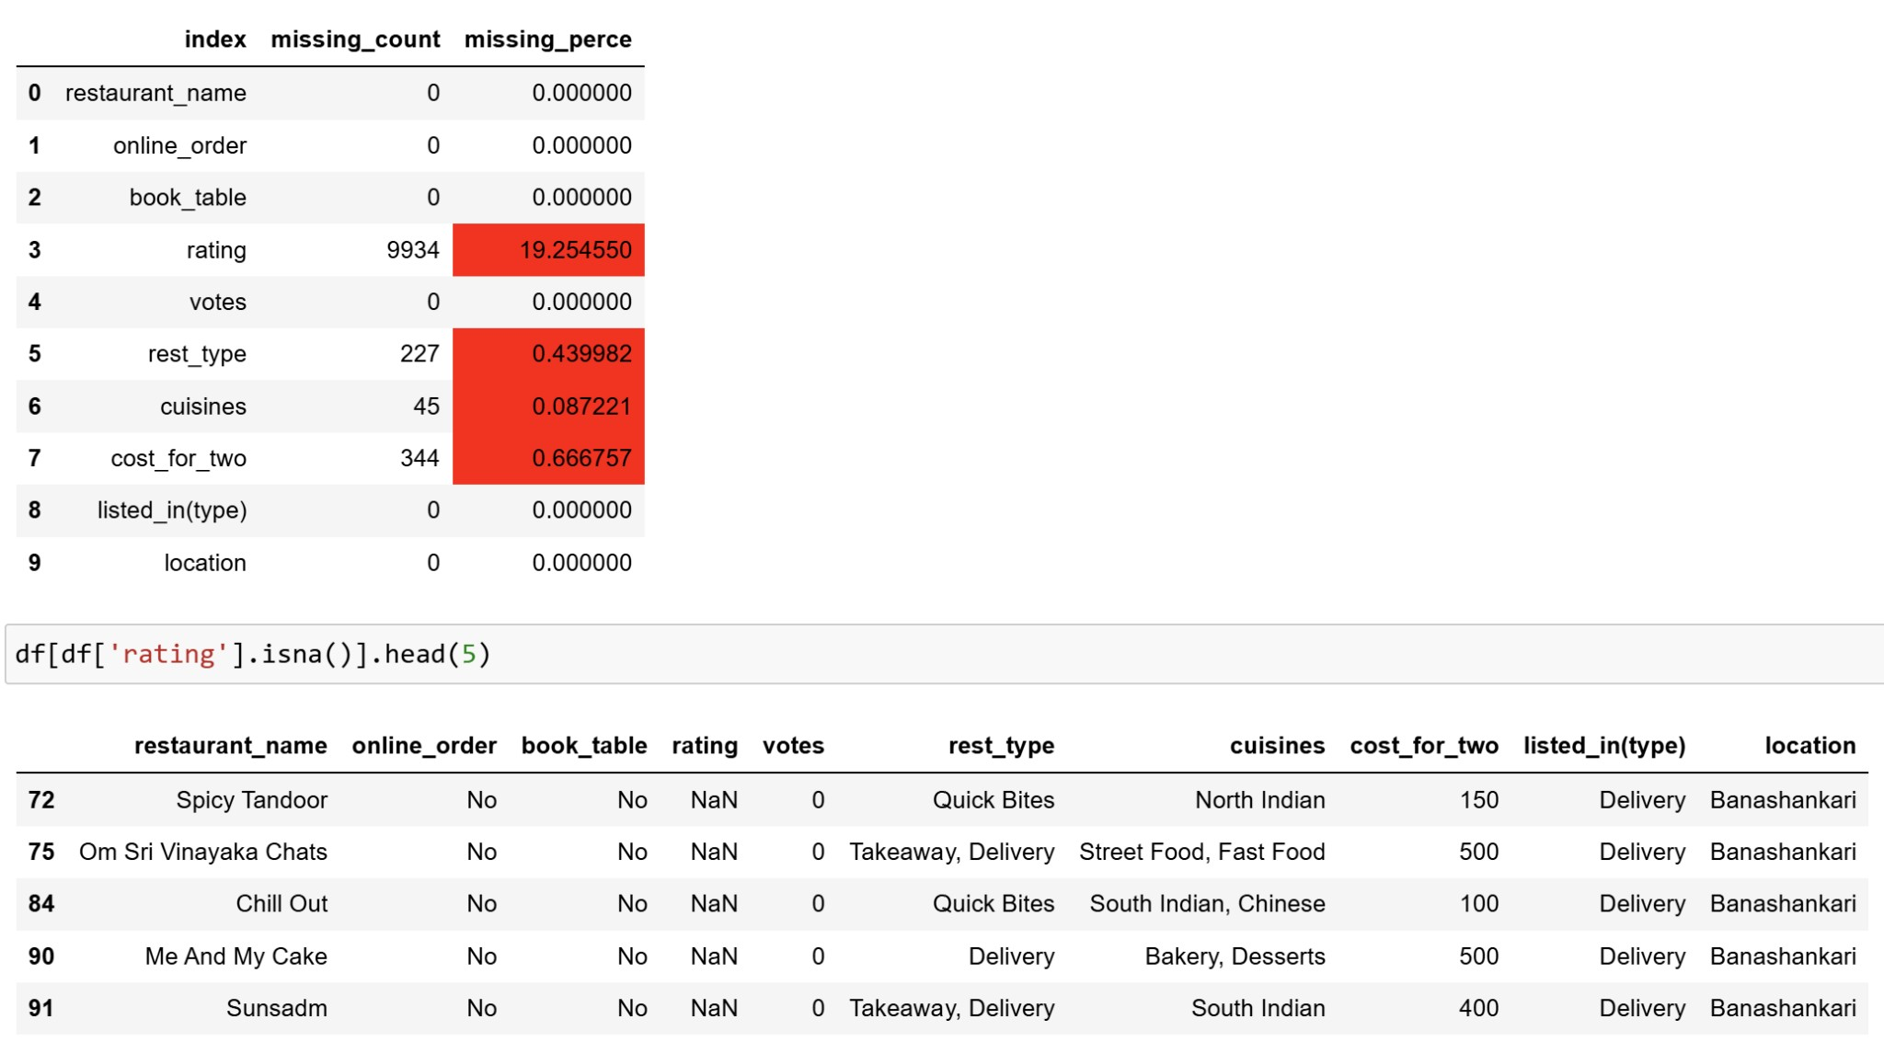

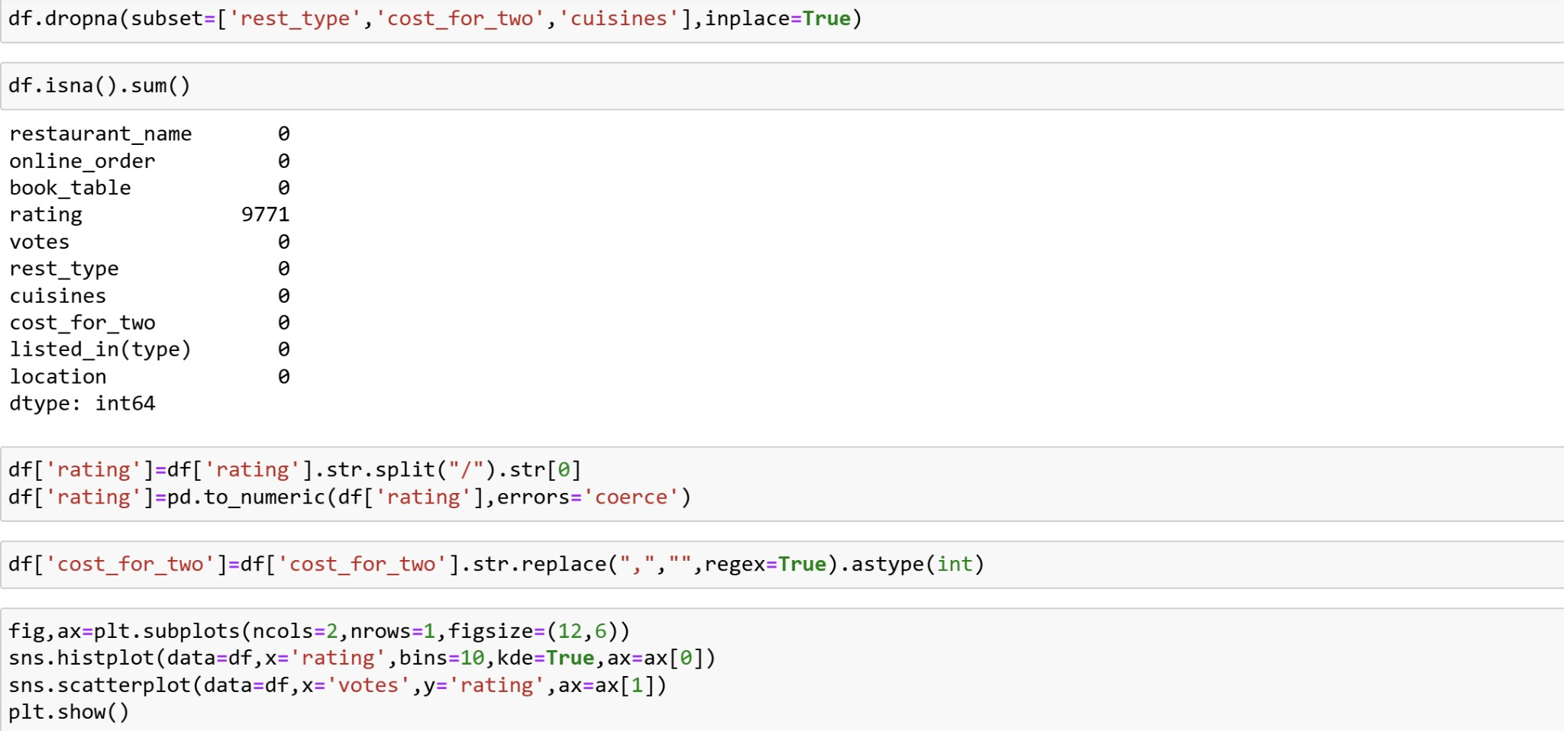

**EDA ANALYSIS : TO DERIVE NECESSARY INSIGHTS**

**3.1 Visualize Data:**

* + Histograms and density plots for numerical features.
  + Bar plots for categorical features.
  + Correlation matrix heatmap to understand relationships between variables

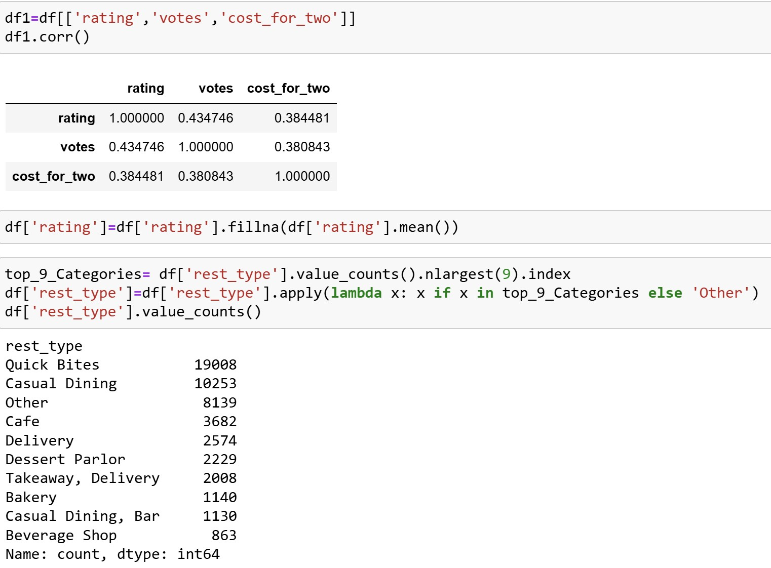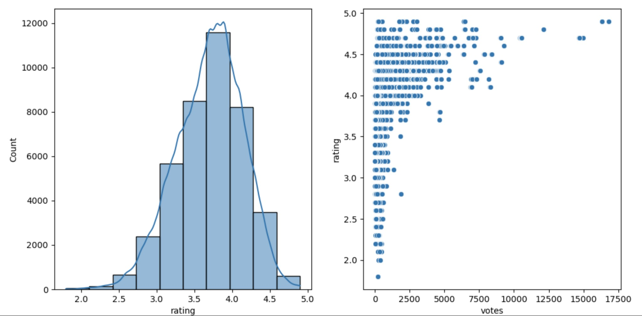

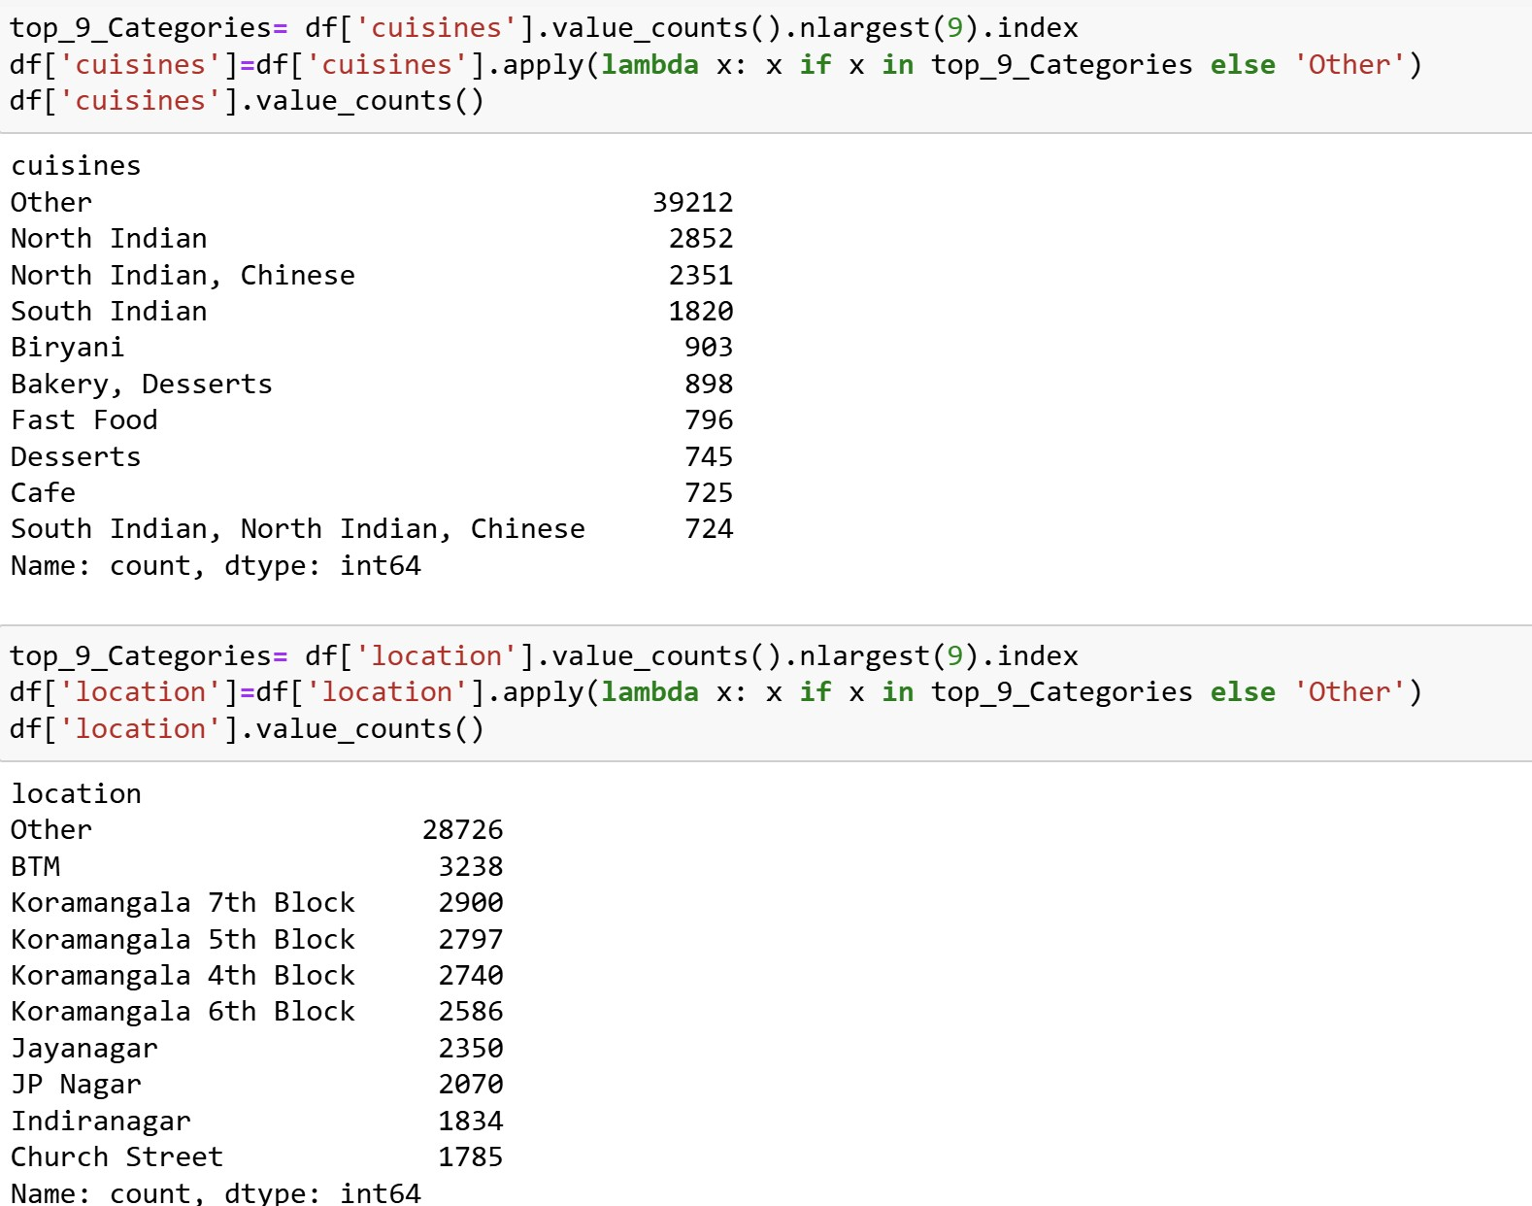

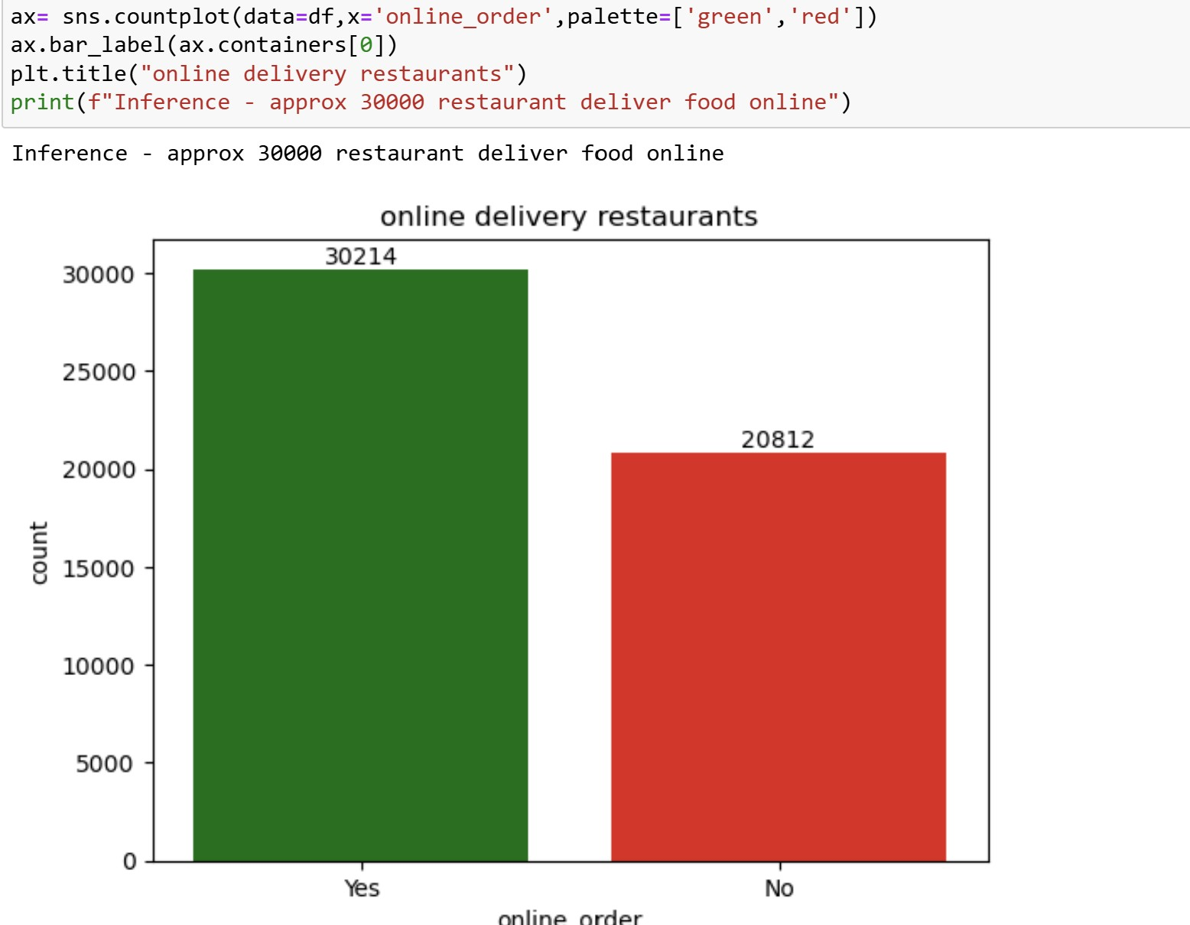

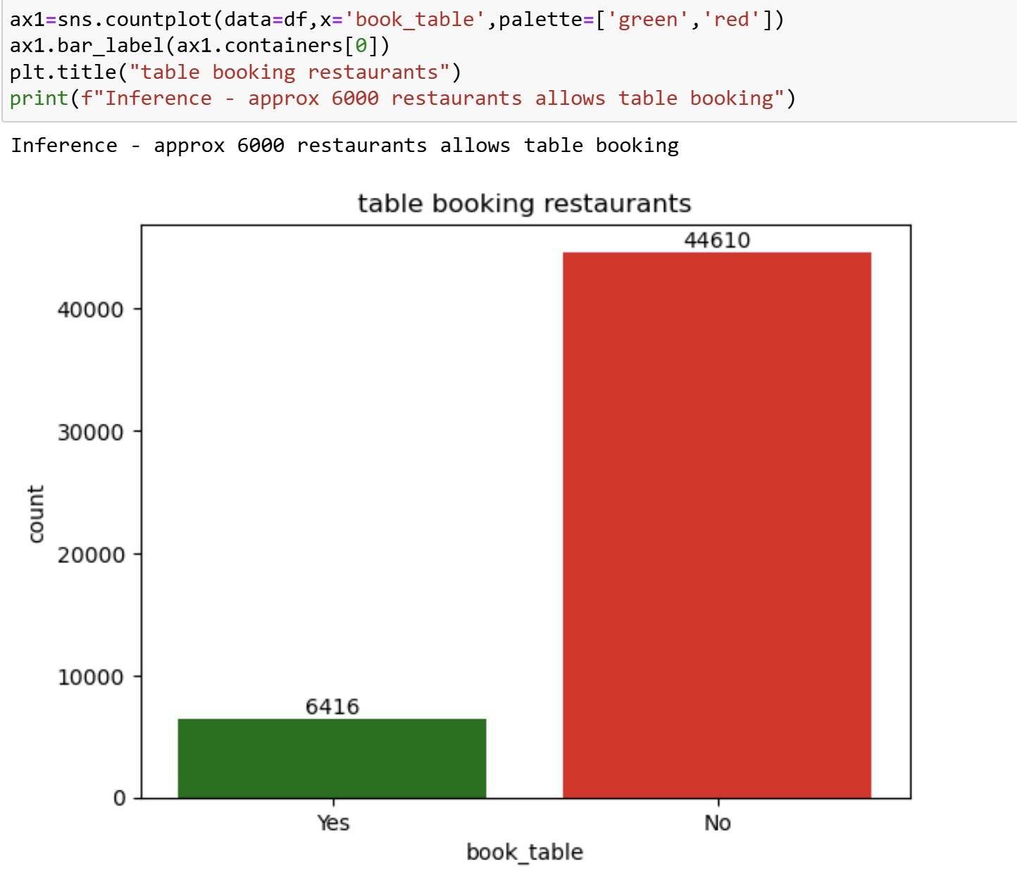

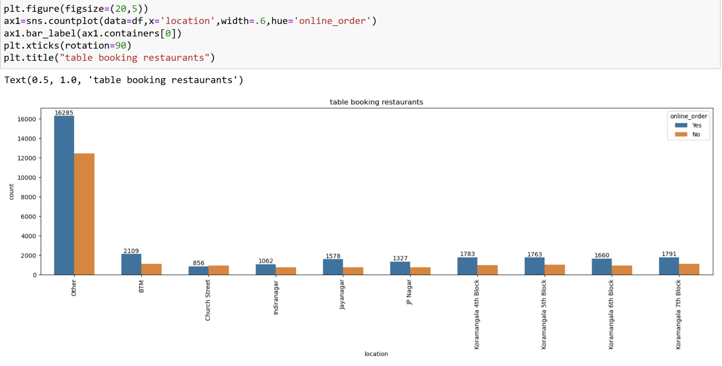

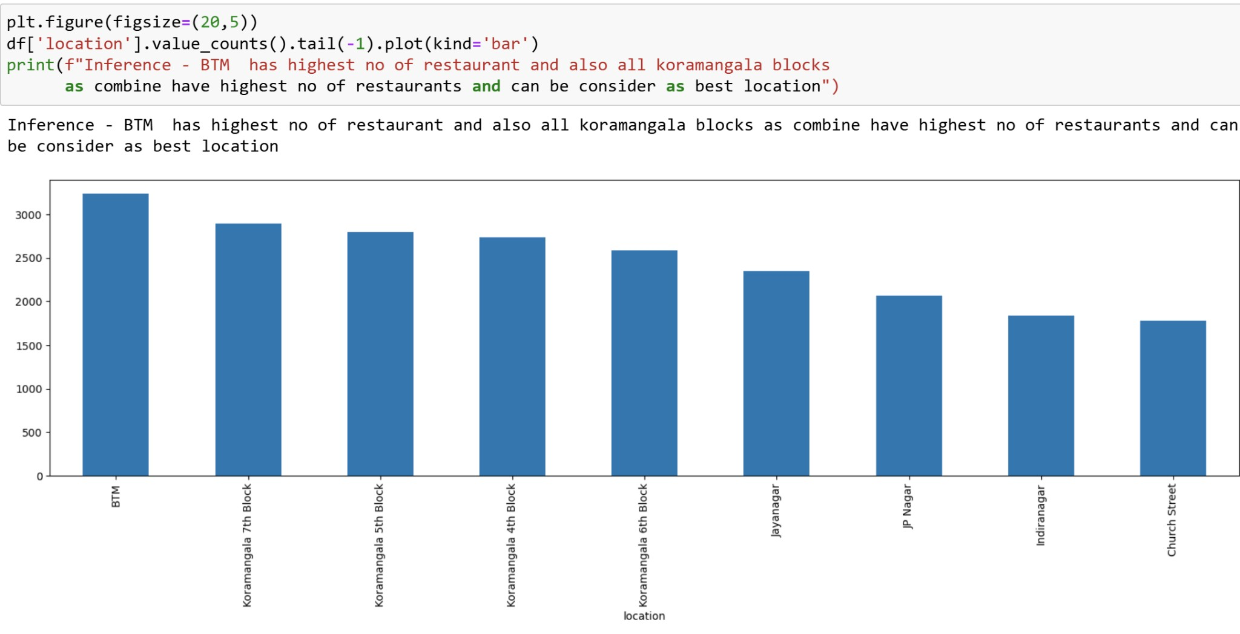

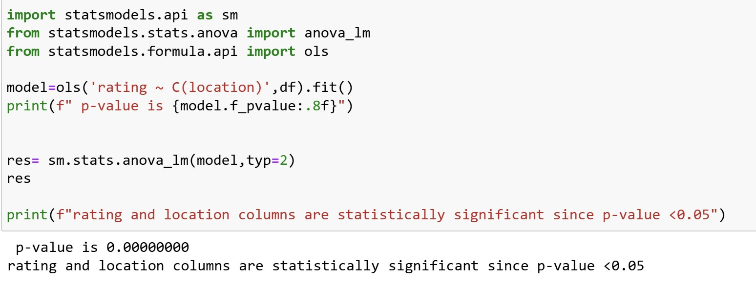

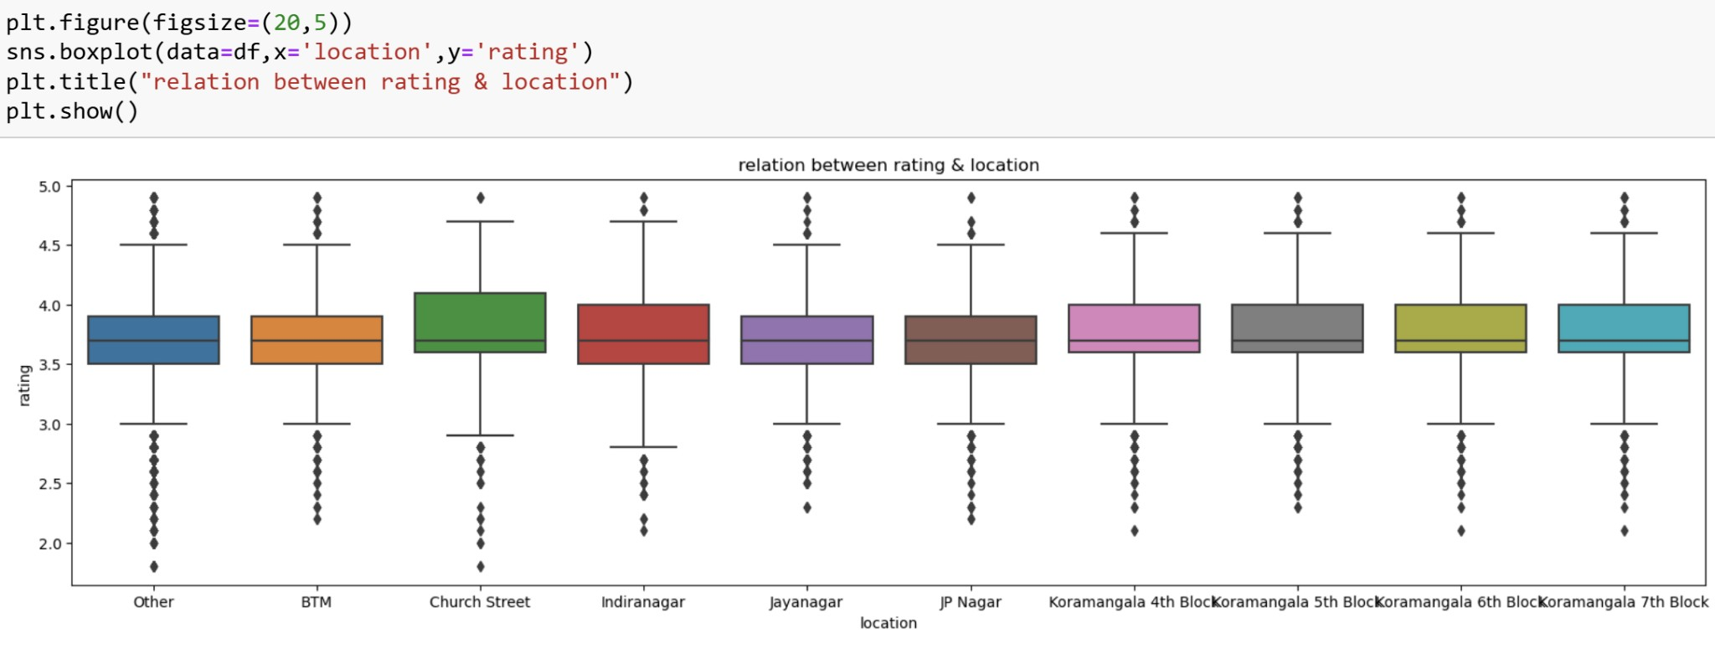

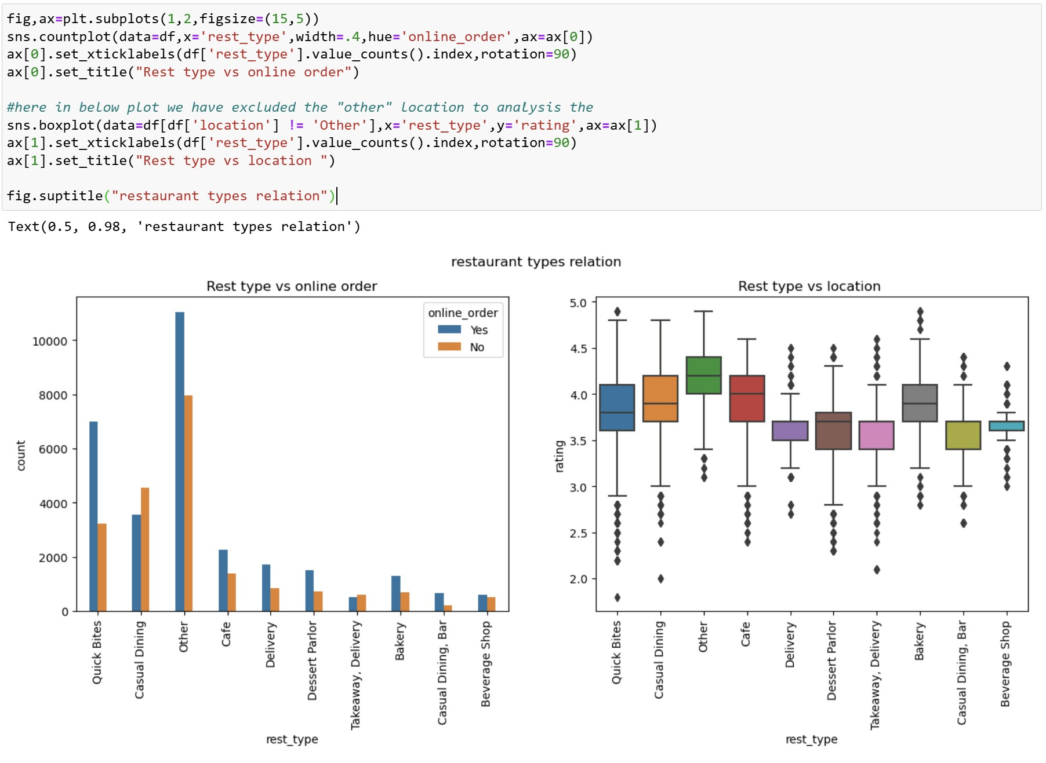

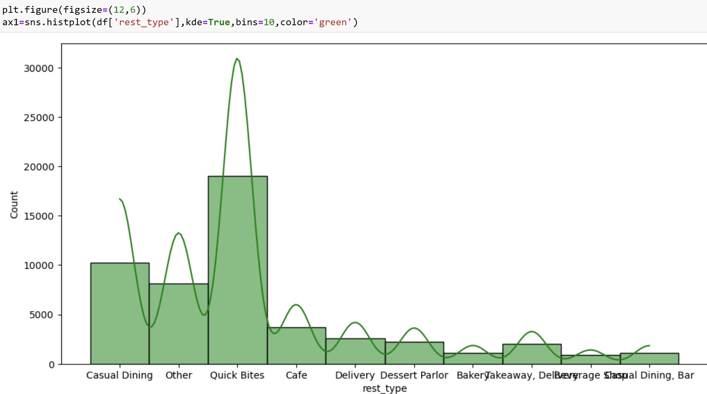

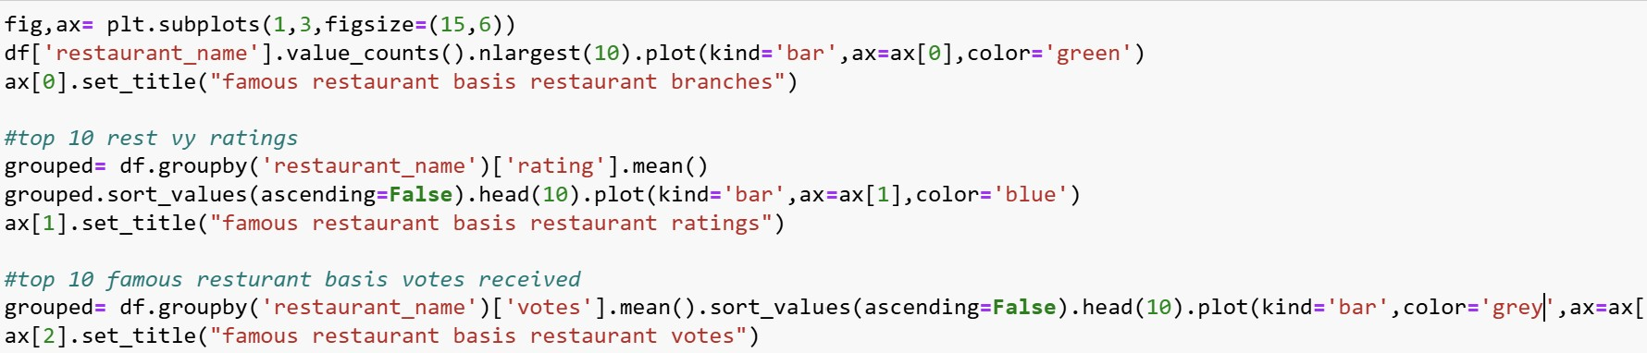

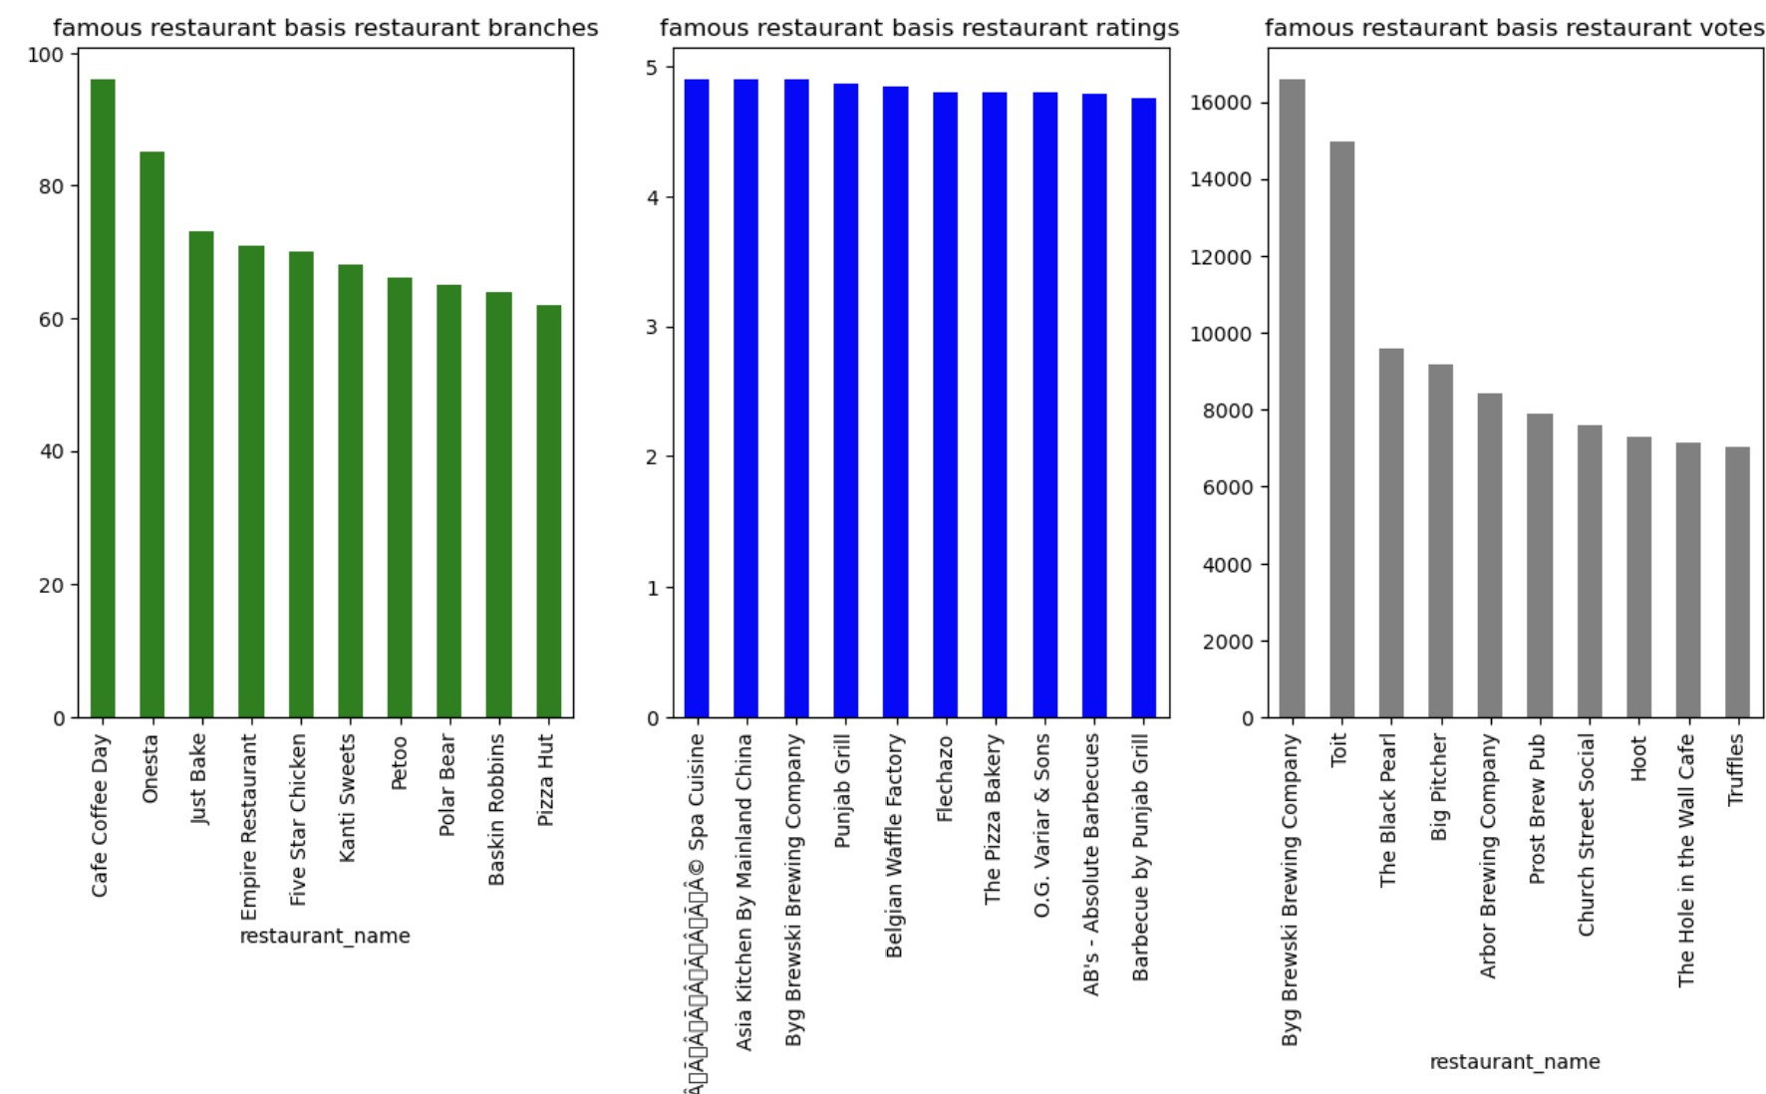

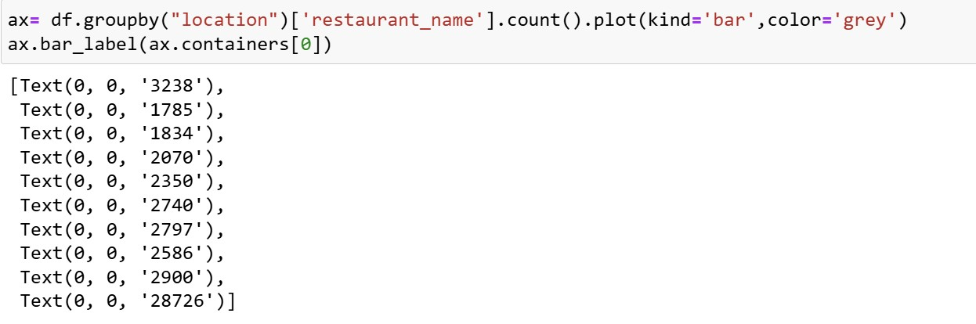

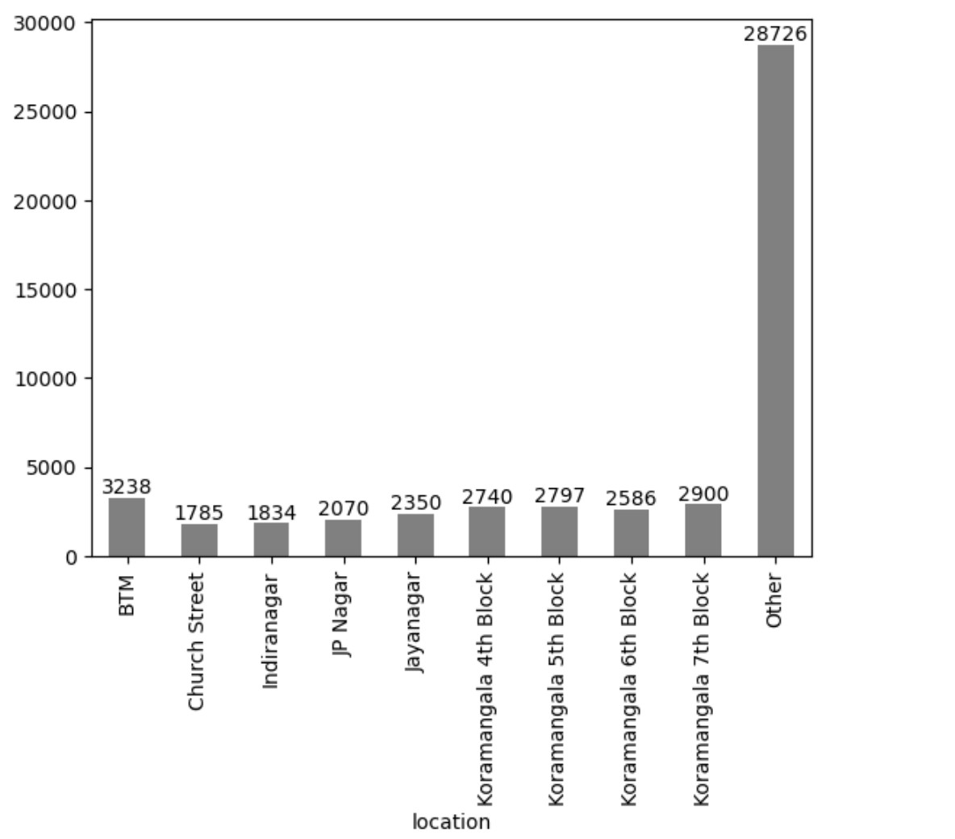

**MODEL TRAINING TO PERFORM PRICE PREDICTION**

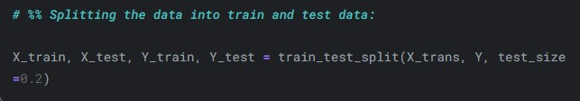

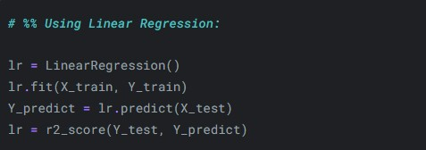

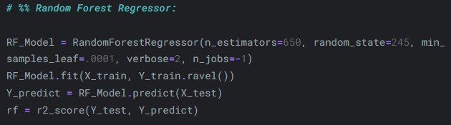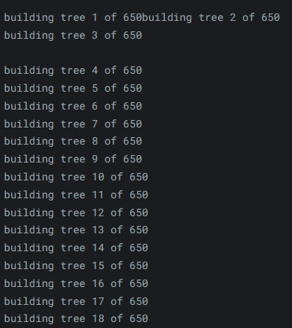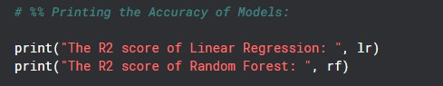





**Results and Discussion**:The best-performing model was identified based on evaluation metrics, indicating it provided the most accurate predictions of restaurant dining costs. Key findings include:

* Influential Features: Ratings, votes, and location emerged as the most influential factors in determining dining cost.
* Model Accuracy: The final model achieved a reasonably high accuracy rate, making it reliable for real-world use in predicting dining costs.

These insights offer potential use cases for Zomato, such as:

* Enhanced Recommendations: By accurately predicting dining costs, Zomato can better cater to users' budget preferences.
* Pricing Optimization: Zomato could use these insights to suggest pricing adjustments or feature restaurants that match user preferences, enhancing engagement

**Conclusion**

:This project successfully developed a predictive model to estimate dining costs for Bangalore restaurants on Zomato. The results highlight the impact of restaurant type, location, and ratings on pricing, providing actionable insights. While the model is effective, further improvements could involve additional attributes (e.g., seasonal pricing trends) and refining model algorithms.

**Future Work:**

* Incorporate more attributes, such as special promotions or time-based pricing, to improve prediction accuracy.
* Test additional advanced models to further reduce error rates and improve reliability.

Through this analysis, Zomato can refine its pricing strategy, potentially increasing user satisfaction and engagement on the platform.